6/3/2021

**Amina Qadeer-359607**

**CE-42-A**

**CO-LAB -11**

**To Maam Rimsha Tariq**

**CO-Progress Report-11**

**CO-POROGRESS REPORT 11:**

**Lab tasks:**

**1. Write the assembly for the following using beq, bge etc**

• if (i==j) f = g+h; else f = g-h;

.data

message1 : .asciiz "if (i==j) f = g+h; else f = g-h;- Prove if Branch are equal"

# f=18

message2 : .asciiz "if (i==j) f = g+h; else f = g-h;- :Prove if Branch not equal"

.text

main:

addi $t0,$zero, 12 # g=12

addi $t1,$zero , 6 # h=6

beq $t0, $t1,addition

bne $t0,$t1, subtraction

# syscall to end a program

j terminate

addition:

add $t3, $t0,$t1

li $v0,4

la $a0, message1

j terminate

subtraction:

sub $t4,$t0,$t1

li $v0,4

la $a0, message2

j terminate

terminate:

li $v0,10

syscall

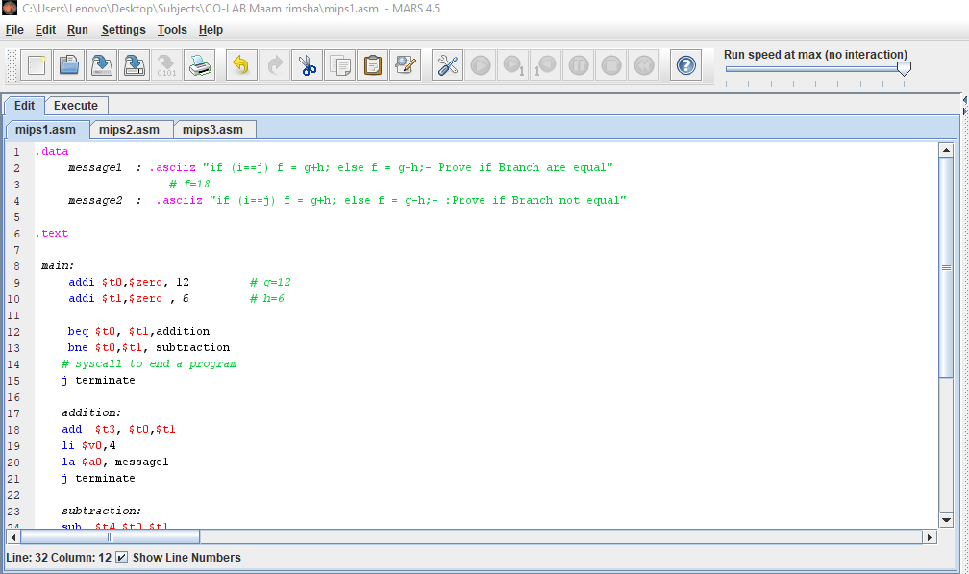

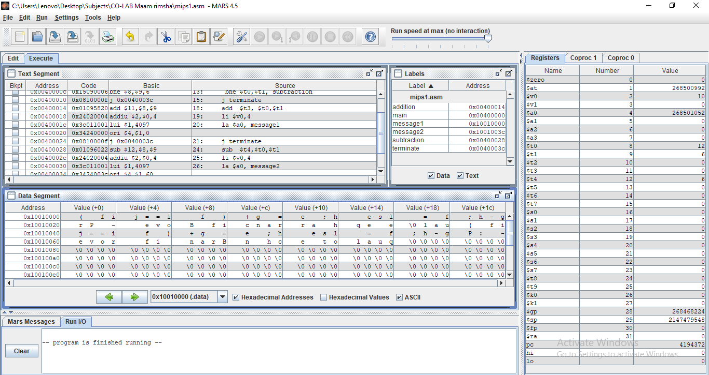

I searched about ascizz instruction and learnt many mistakes as progress of this task in class.

• If (i! =j) f = g+h; else f = g-h;

• if (i>j) f = g+h; else f = g-h;

• if (i>=j) f = g+h; else f = g-h;

• if (i<j) f = g+h; else f = g-h;

• if (i<=j) f = g+h; else f = g-h